PROBLEM 1
Title : Maximum of Three Numbers
Objective:
The objective of this program is to find the largest number among three given integers using different conditional approaches in C programming.
Problem Statement:
The program takes three integer inputs from the user and determines the maximum value using three different methods:
- Using only if statements
- Using if-else if-else statements
- Using nested if-else statements
Approach:
First, three integer values are taken as input from the user. Then, different conditional structures are applied to compare the values and identify the largest number. The result is stored in a variable and displayed as output.
Source Code / Solution:
Option i: Using only if statements
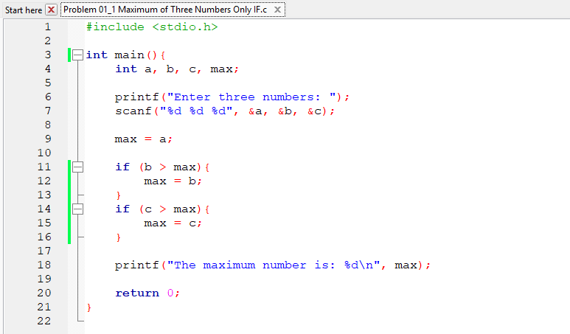

Option ii: Using if–else if–else Statement
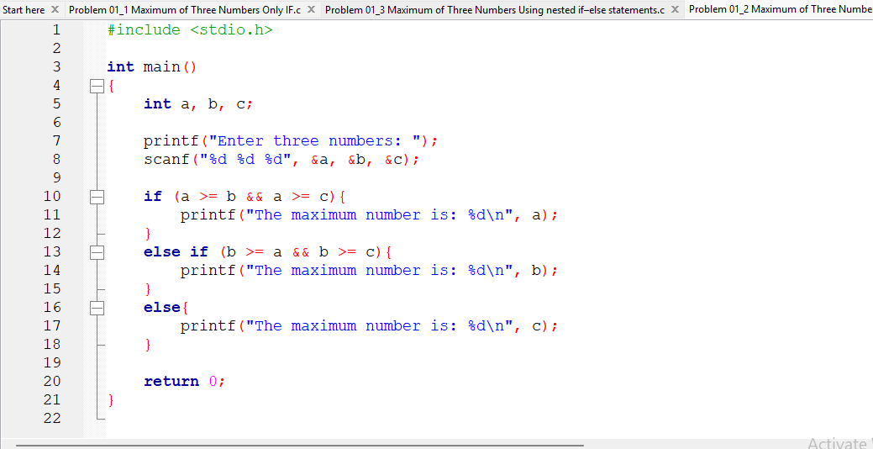
Option iii: Using nested if–else Statement
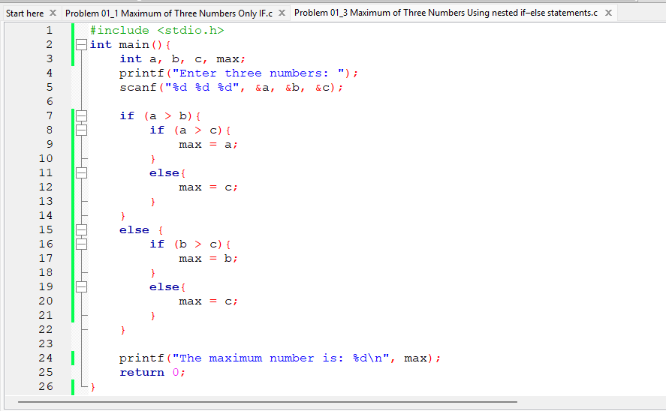
Outputs & Results
Sample Input:

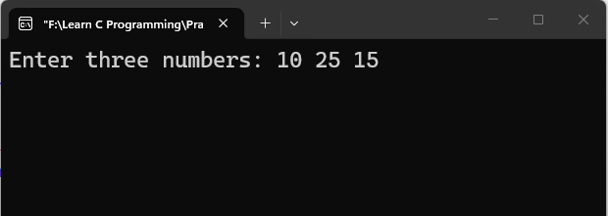
Sample Output:
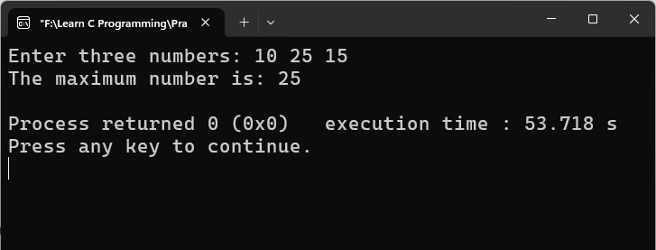
Analysis & Discussion:
This program demonstrates different ways of solving the same problem using conditional statements. All three approaches produce the same result, but they differ in structure and readability. The nested and if-else methods are more structured, while the simple if only method is more straightforward.

PROBLEM 2
Title : Vowel or Consonant Checker
Objective:
The objective is to determine whether a given character is a vowel, consonant, or an invalid character.
Problem Statement:
The program takes a single character input (case-insensitive) and classifies it into one of the following categories:
- Vowel
- Consonant
- Unidentified character

Approach:
The input character is first converted to lowercase if it is uppercase. Then it is checked whether it belongs to the English alphabet. Finally, it is compared with vowels to determine the correct category.
Source Code / Solution:
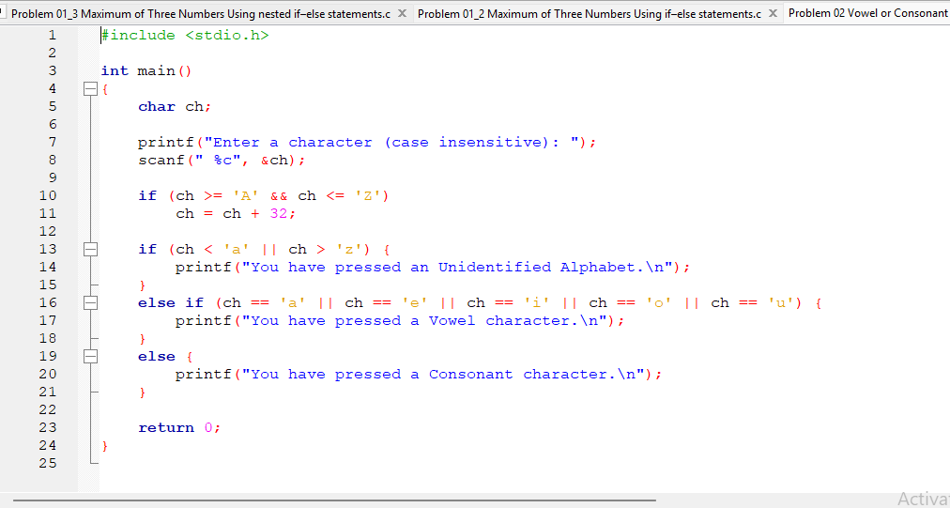

Outputs & Results:
Sample Input 1:
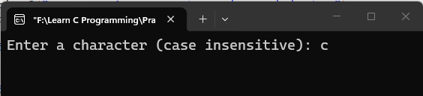
Sample Output 1:
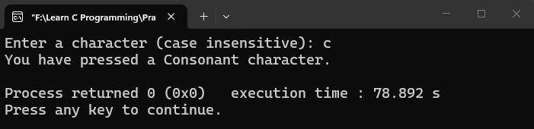
Sample Input 2:
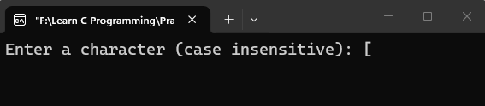
Sample Output 2:
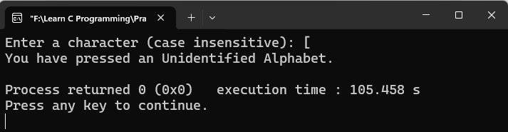
Sample Input 3:
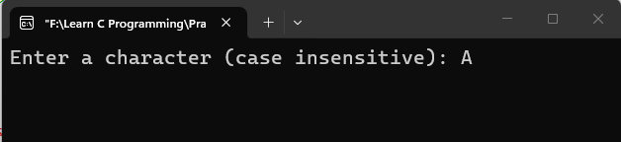
Sample Output 3:
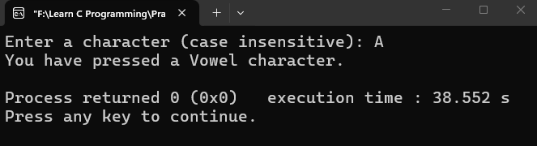

Analysis & Discussion:
This program uses ASCII logic to handle character classification. It also includes input validation and case conversion, making it more robust and user-friendly.

PROBLEM 3
Title: Reverse a Two-Digit Number
Objective:
To reverse a two digit number provided by the user.
Problem Statement:
- The program accepts an integer input and:
- Reverses it if it is a valid two-digit number
- Displays an error message if the number has more than two digits
Approach:
The program checks whether the number is within the valid two-digit range (10–99). If valid, it extracts digits using modulus and division operations and constructs the reversed number.
Source Code / Solution:
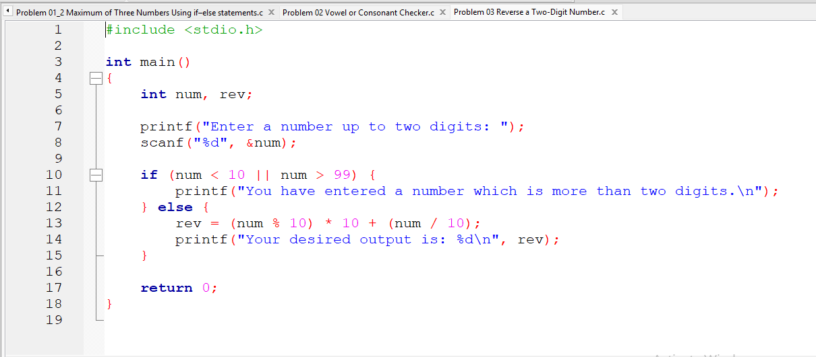
Outputs & Results:
Sample Input 1:
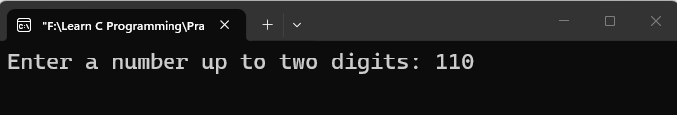
Sample Output 1:
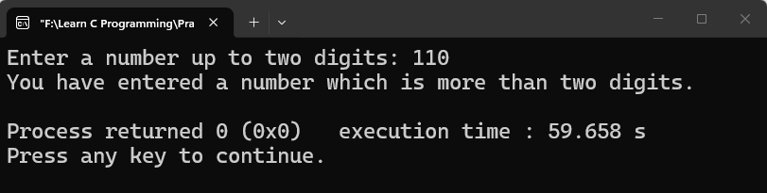
Sample Input 2:
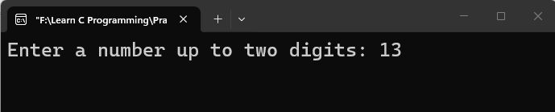
Sample Output 2:
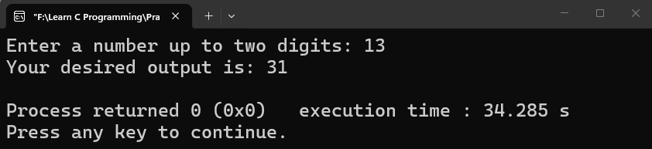

Analysis & Discussion:
This program demonstrates basic number manipulation using arithmetic operations. It helps understand how digits can be extracted and rearranged using modulus and division.

PROBLEM 4
Title: Lowercase to Uppercase Conversion
Objective:
To convert a lowercase letter into its uppercase equivalent using ASCII values.
Problem Statement:
The program takes a lowercase letter as input and converts it into uppercase. If the input is invalid, an error message is displayed.
Approach:
The program checks whether the input is a lowercase letter. If valid, it subtracts 32 from its ASCII value to get the uppercase equivalent.
Source Code / Solution:
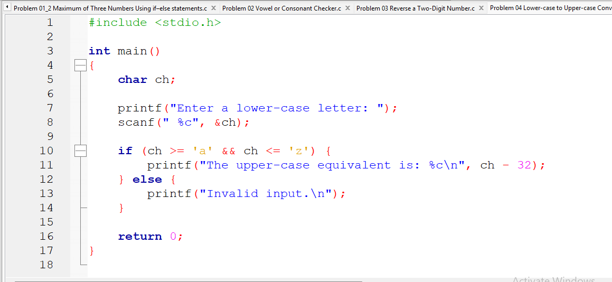
Outputs & Results:
Sample Input:
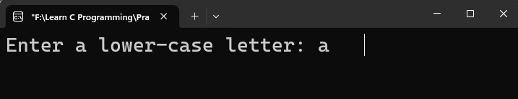
Sample Output:
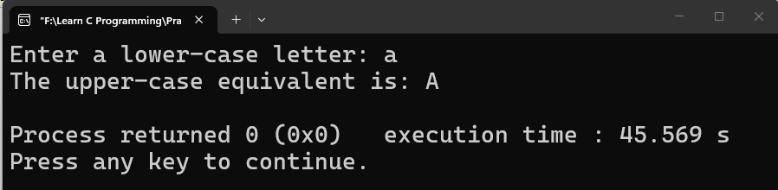
Analysis & Discussion:
This program uses ASCII value manipulation to perform character conversion. It is a fundamental concept in C programming for understanding how characters are stored and processed.

